Name : Fariha Arai

AF ID : AF0443236

Lab 6

**1. Write a python program to reverse a number using a while loop.**

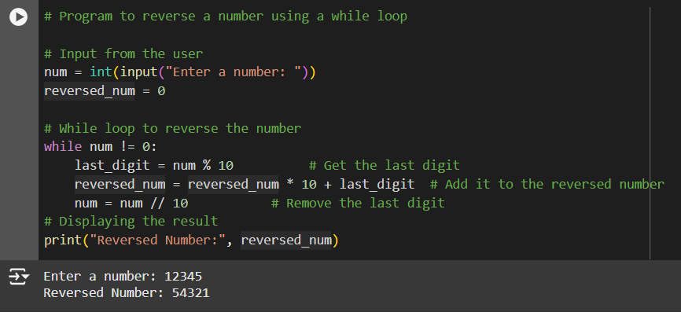

**2. Write a python program to check whether a number is palindrome or not?**

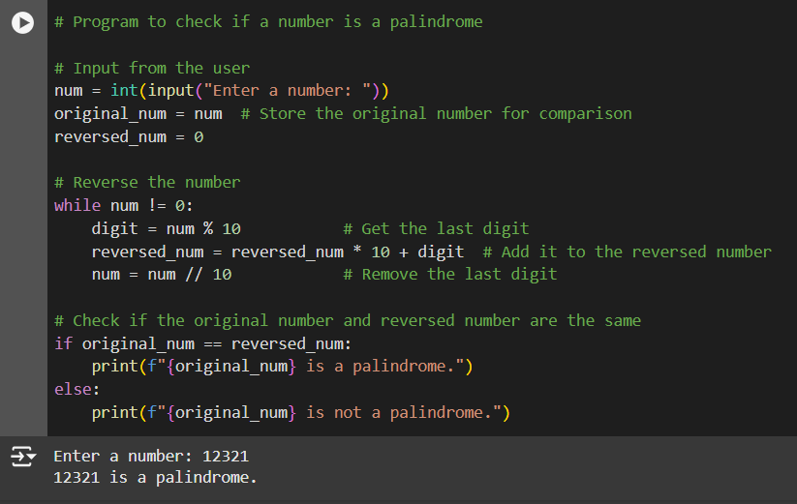

**3. Write a python program finding the factorial of a given number using a while loop.**

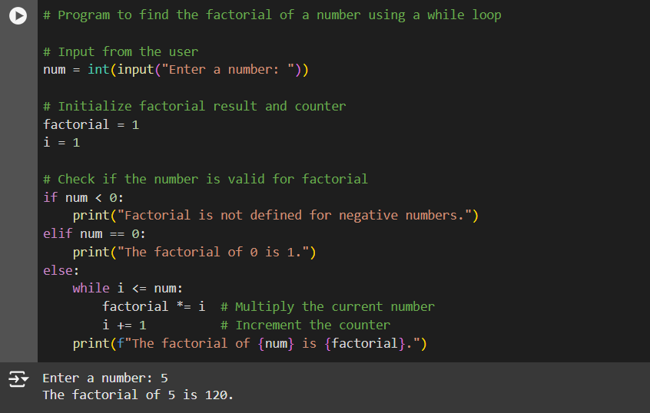

**4. Accept numbers using input() function until the user enters 0. If user input 0 then break the while loop and display the sum of all the numbers.**

